Opsview Redundancy
Configuration

Contents
1. Overview 1
1.1. Purpose 1
1.2. Requirements 1
2. Mysql Master-Master Replication 2
2.1. etc/my.cnf 2
2.2. Setting Up Replication 2
3. Heartbeat Configuration 4
3.1. Heartbeat Installation 4
3.2. Heartbeat Configuration 4
3.3. Post-Heartbeat Service Setup 5
3.4. Mon Installation 5
3.5. Mon Configuration 5
4. File System Synchronization 6
4.1. Recommended Standard 6
4.2. Alternative Solution 6
5. Monitoring Replication Health 8
5.1. Monitoring mysql Replication 8

Overview

Purpose
    - The purpose of this document is to aid in the creation of a redundant opsview environment. The design that will be implemented is taken from the documentation at opsview.com. The way this will work is that the databases will be configured in master-mater replication mode allowing the standby server to take over at any time. However, only one opsview server can actually be running at a time.

Requirements
    - Two Opsview Servers, virtual or physical, it doesn’t matter, but for the purpose of this document, we will call them Opsview1 and Opsview2 respectively.
    - FQDN. Each machine must be able to resolve the other via their fqdn.
    - Update to date Opsview install (see opsview installation documentation)
    - The UID and GID for the nagios user, group and nagcmd group MUST be the same. Filesystem failover will not work without this. If the IDs are not the same, change the UID and GIDs respectively, then uninstall and reinstall opsview.
    - Updated mysql and mysql-server on CentOS or RHEL.
    - EPEL Repository is required to install heartbeat.
$> rpm -ivh http://mirror.pnl.gov/epel/6/i386/epel-release-6-8.noarch.rpm
(Current as of 2-14-2014)

Mysql Master-Master Replication

/etc/my.cnf
    - When setting up the master-master replication, it is important that both opsview servers have opsview shutdown. We do not want it actively writing to the databases.
    - On Opsview1: Add the following lines under the [mysqld] section of my.cnf servers. Be sure that the setting server-id= is set to a unique id.
[mysqld]
…
log-bin=mysql-bin
server-id=UNIQUE_ID ( example: server-id=1, server-id=2)
innodb_flush_log_at_trx_commit=1
innodb_autoinc_lock_mode=0
auto_increment_increment=2
auto_increment_offset=1
sync_binlog=1

    - On Opsview2: Add the following lines under the [mysqld] section of my.cnf servers. Be sure that the setting server-id= is set to a unique id.
[mysqld]
…
log-bin=mysql-bin
server-id=UNIQUE_ID ( example: server-id=1, server-id=2)
innodb_flush_log_at_trx_commit=1
innodb_autoinc_lock_mode=0
auto_increment_increment=2
auto_increment_offset=2
sync_binlog=1

    - Restart mysqld.
$> service mysqld restart

Setting Up Replication
    - Make a backup of all databases on opsview1 and import them into opsview2.
On Opsview1 $> mysqldump -u root -p[password] --all-databases > dbdump.db
On Opsview2 $> mysql -u root -p[password] < dbdump.db

    - On Opsview1: Log into mysql on opsview1
$> mysql -u root -p[mysqlrootpassword]
    - On Opsview1 AND Opsview2: Run the following command to create a new user and password that will be used for replication. This needs to be completed on both opsview1 and opsview2.
mysql> grant replication slave on *.* to ‘replication’@’opsview2.fqdn.com’ identified by ‘slavepass’;
    - On Opsview1: Run the two following commands and take note of the File and Position as these will be used to setup the slave replication on opsview2.
mysql> flush tables with read lock;
mysql> show master status;

    - On Opsview2: Log into mysql on opsview2 and run the following commands with the information you just gathered.
mysql> change master to
-> master_host=’opsview1’,
-> master_user=’replication’,
-> master_password=’slavepass’,
-> master_log_file=’recorded_log_file_name_from_previos_step’,
-> master_log_pos=recorded_log_position_from_previous_step;

    - On Opsview2: Start the slave
mysql> start slave;

    - On Opsview2: Look for errors.
mysql> show slave status\G;

    - On Opsview2: Tail the log file with a -f and look for any errors.
$> tail -f /var/log/mysqld.log

    - On Opsview2: Run the two following commands and take note of the File and Position as these will be used to setup the slave replication on opsview1.
mysql> flush tables with read lock;
mysql> show master status;

    - On Opsview1: Log into mysql and run the following commands with the information you just gathered.
mysql> change master to
-> master_host=’opsview1’,
-> master_user=’replication’,
-> master_password=’slavepass’,
-> master_log_file=’recorded_log_file_name_from_previos_step’,
-> master_log_pos=recorded_log_position_from_previous_step;

    - On Opsview1: Start the slave
mysql> start slave;

    - On Opsview1: Look for errors.
mysql> show slave status\G;

    - On Opsview1: Tail the log file with a -f and look for any errors.
$> tail -f /var/log/mysqld.log

    - Start the opsview and opsview-web service up on only one server. Continue to watch mysqld.log on both servers and watch for errors.

Heartbeat Configuration
Now that the databases are syncing with each other in master-master mode, we need to configure heartbeat and mon so that if opsview1 goes down opsview2 will take over and so on and so forth.

Heartbeat Installation
    - Install heartbeat.
$> yum install heartbeat

Heartbeat Configuration
    - On Opsview1: Create the file /etc/ha.d/ha.cf with the following content.
debugfile /var/log/ha-debug
logfile /var/log/ha-log
logfacility local0
keepalive 2
warntime 10
deadtime 30
initdead 90
udpport 694
ucast eth0 192.168.122.6 ## IP for opsview2
node opsview1.example.local
node opsview2.example.local
auto_failback off

    - On Opsview2: Create the same file on opsview2 except change the IP address where it says ucast eth0 to the IP of opsview1.
    - On Opsview1 and Opsview 2: Create the file /etc/ha.d/haresources with the following content on both servers.
opsview1.example.local IPaddr::192.168.122.65 opsview opsview-web

    - On Opsview1 and Opsview 2: Create the file /etc/ha.d/authkey with the following content on both servers.
auth 1
1 crc

Post-Heartbeat Service Setup
    - On Opsview1 and Opsview 2: Disable opsview and opsview web services from auto starting.
$> chkconfig opsview off
$> chkconfig opsview-web off

    - On Opsview1 and Opsview 2: Start the heartbeat service and ensure it is enabled on startup.
$> service heartbeat start
$> chkconfig heartbeat on

    - On Opsview1 and Opsview 2: Tail the log and ensure there are no issues with heartbeat.
$> tail -f /var/log/ha-log

Mon Installation
    - On Opsview1 and Opsview 2: Install mon. This enables the monitoring of the opsview service so that if the application loses its mind, heartbeat can put the system in standby and bring the other node up.
$> yum install mon -y

Mon Configuration
    - On Opsview1 and Opsview 2: Edit the /etc/mon/mon.cf file and replace the contents below the “### group definitions (hostnames or IP addresses)” so it looks like the following.
### group definitions (hostnames or IP addresses)
hostgroup servers localhost

watch servers
service http
interval 15s
monitor http.monitor -p 3000
allow_empty_group
period wd {Mon-Sun}
alertafter 3
alert force-hb-failover.alert

    - On Opsview1 and Opsview 2: Create a file in /usr/lib64/mon/alert.d named force-hb-failover.alert with the following line, save the file and make it executable.
/usr/share/heartbeat/hb_standby
$> chmod +x /usr/lib64/mon/alert.d/force-hb-failover.alert

    - On Opsview1 and Opsview 2: Update the /etc/ha.d/haresources file to include mon
opsview1.example.local IPaddr::192.168.122.65 mon opsview opsview-web

File System Synchronization
The final piece of the puzzle is to ensure that all of the event data, plugins, etc. are all synchronized between both servers.

Recommended Standard
    - The best and most robust option is to utilize a shared storage solution and mount this shared storage to /usr/local/nagios on both servers. This will ensure that current event data, plugins, etc. are all synchronized and available if the other server goes down.
Note: NFS has not yet been tested successfully. Tests so far have proven inconsistent and laggy.

Alternative Solution
If shared storage is not an option for one reason or another, an alternative can be achieved through the usage of drbd. DRBD stands for Distributed Replicated Block Device and is essentially a way of mirroring (RAID 1) over the network. Follow the below steps to configure drbd on both systems.
    - On Opsview1 and Opsview 2: Ensure at least 10GB of disk space is available on both machines. Space can be in the form of a physical disk, available partition or possibly a disk image. Either way, it is recommended, but not necessary, to partition the free space as a Logical Volume partition but do not format it. This will allow for space to be added easily if needed in the future. See the Linux Standards document for details on how to set up LVM.
    - On Opsview1 and Opsview 2: Ensure ntp is configured. See the Linux Standards documentation for details on setting up ntp.
    - On Opsview1 and Opsview 2: Ensure ntp is configured and also ensure that both servers can ping each other via their fqdn. Add entries to /etc/hosts if absolutely necessary.
    - On Opsview1 and Opsview 2: Begin by setting up the ELRepo.
$> rpm -Uvh http://www.elrepo.org/elrepo-release-6-5.el6.elrepo.noarch.rpm

    - On Opsview1 and Opsview 2: Install drbd83 and kmod-drbd83 packages.
$> yum install drbd83-utils kmod-drbd83 -y
    - On Opsview1 and Opsview 2: Load the drbd module (This is only necessary the first time as it will load on boot from this point forward).
$>modprobe drbd
    - On Opsview1 and Opsview 2: Create a file in /etc/drbd.d/disk1.res with the following content. Note: replace “disk /dev/vg_drbd/lv_nag” with the logical volume that was prepared previously.
$>vi /etc/drbd.d/disk1.res
resource disk1
{
startup {
wfc-timeout 30;
outdated-wfc-timeout 20;
degr-wfc-timeout 30;
}
net {
cram-hmac-alg sha1;
shared-secret sync_disk;
}
syncer {
rate 100M;
verify-alg sha1;
}
on opsview1.example.local {
device minor 1;
disk /dev/vg_drbd/lv_nag;
address 192.168.122.158:7789;
meta-disk internal;
}
on opsview2.example.local {
device minor 1;
disk /dev/vg_drbd/lv_nag;
address 192.168.122.6:7789;
meta-disk internal;
}
}
    - On Opsview1 and Opsview 2: Edit the /etd/drbd.d/global_common.conf file and change the usage-count setting to “usage-count no;”
    - On Opsview1 and Opsview 2: Initialize the drbd meta data storage.
$> drbdadm create-md disk1
    - On Opsview1 and Opsview 2: Start the drbd service.
$> service drbd start
    - On Opsview1: Make the system the primary.
$> drbdadm -- --overwrite-data-of-peer primary disk1
    - On Opsview1: Create the filesystem on /dev/drbd1.
$> mkfs.ext4 /dev/drbd1
    - On Opsview1: Update the heartbeat haresources file with the following.
Add “drbddisk::disk1 Filesystem::/dev/drbd1::/usr/local/nagios::ext4”
So the whole file should look like the following
opsview1.example.local IPaddr::192.168.122.65 drbddisk::disk1 Filesystem::/dev/drbd1::/usr/local/nagios::ext4 mon opsview opsview-web opsview-agent

Monitoring Replication Health
Now that replication is up and running, it is important to ensure the replication is monitored in case there are any issues. This is mainly true with the database.

Monitoring mysql Replication
    - Setup a user that will be used specifically to monitor the replication. Note: Only do this on the currently active server. It will replicate the settings to the other server.
mysql$> grant select,super,replication client on *.* to 'monitor'@'opsview1' identified by 'M0n1t0rTh15';
mysql$> grant select,super,replication client on *.* to 'monitor'@'opsview2' identified by 'M0n1t0rTh15';
    - Create a new attribute in Opsview to hold the mysql credentials as seen in the below image.
In Opsview: Settings -> Attributes -> Click the plus sign.
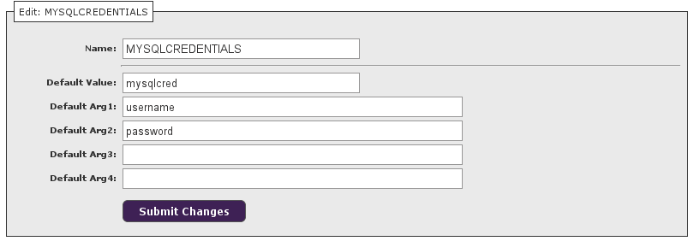
    - Create a new service check as seen in the below image.
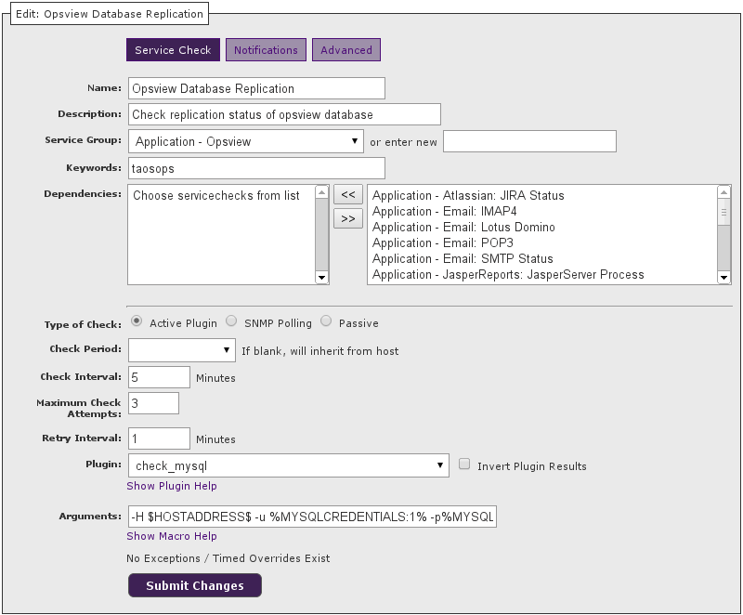
Note: The keywords are not required.
Note: Arguments should be: -H $HOSTADDRESS$ -u %MYSQLCREDENTIALS:1% -p%MYSQLCREDENTIALS:2% -S -w 60 -c 300
    - Go to each host in opsview and under the monitor tab, add the new service check, then go to the attributes tab, select MYSQLCREDENTIALS, expand the attribute and fill in the username and password.
    - Reload opsview and make sure the checks are working properly.

